True distortion-free recording
World first: Sennheiser EW-DP SKP plug-on transmitter with 32-bit float recording and 134 dB input dynamic range

Wedemark, 15 September 2023 – At the end of October, the EW-DP SKP plug-on transmitter will complete the EW-DP series for videographers, broadcasters, and filmmakers. On board: 32-bit float recording, which – in combination with the series’ market-leading 134 dB dynamic range of the transmitter – ensures distorted audio is a thing of the past. No matter what signal is to be recorded on location, whether a whisper or an aircraft taking off, everything can be handled by the SKP without the videographer having to reset levels. Video recording will become faster, easier, and totally reliable.

“Unlike many competitors who offer 32-bit float recording, but not the means to really benefit from this technology as their transmitter limits the dynamic range right on the input side, Sennheiser gives you the industry’s best dynamic input range of 134 dB and 32-bit float – you could call this ‘true’ 32-bit float recording,” says Tobias von Allwörden, head of Sennheiser’s Audio for Video portfolio. “Combine this unique transmitter with a high-quality microphone, and you will have an incredible dynamic range, and incredible detail, too, without having to adjust the gain all the time– ideal for run and gun videography and cinematography.”

The recording function of the EW-DP SKP plug-on transmitter is like a safety net for the user, with a safety copy of their audio being stored on a micro SD card. The SKP additionally offers 24-bit, 48 kHz recording so that videographers can also opt for this less memory-intensive recording format.

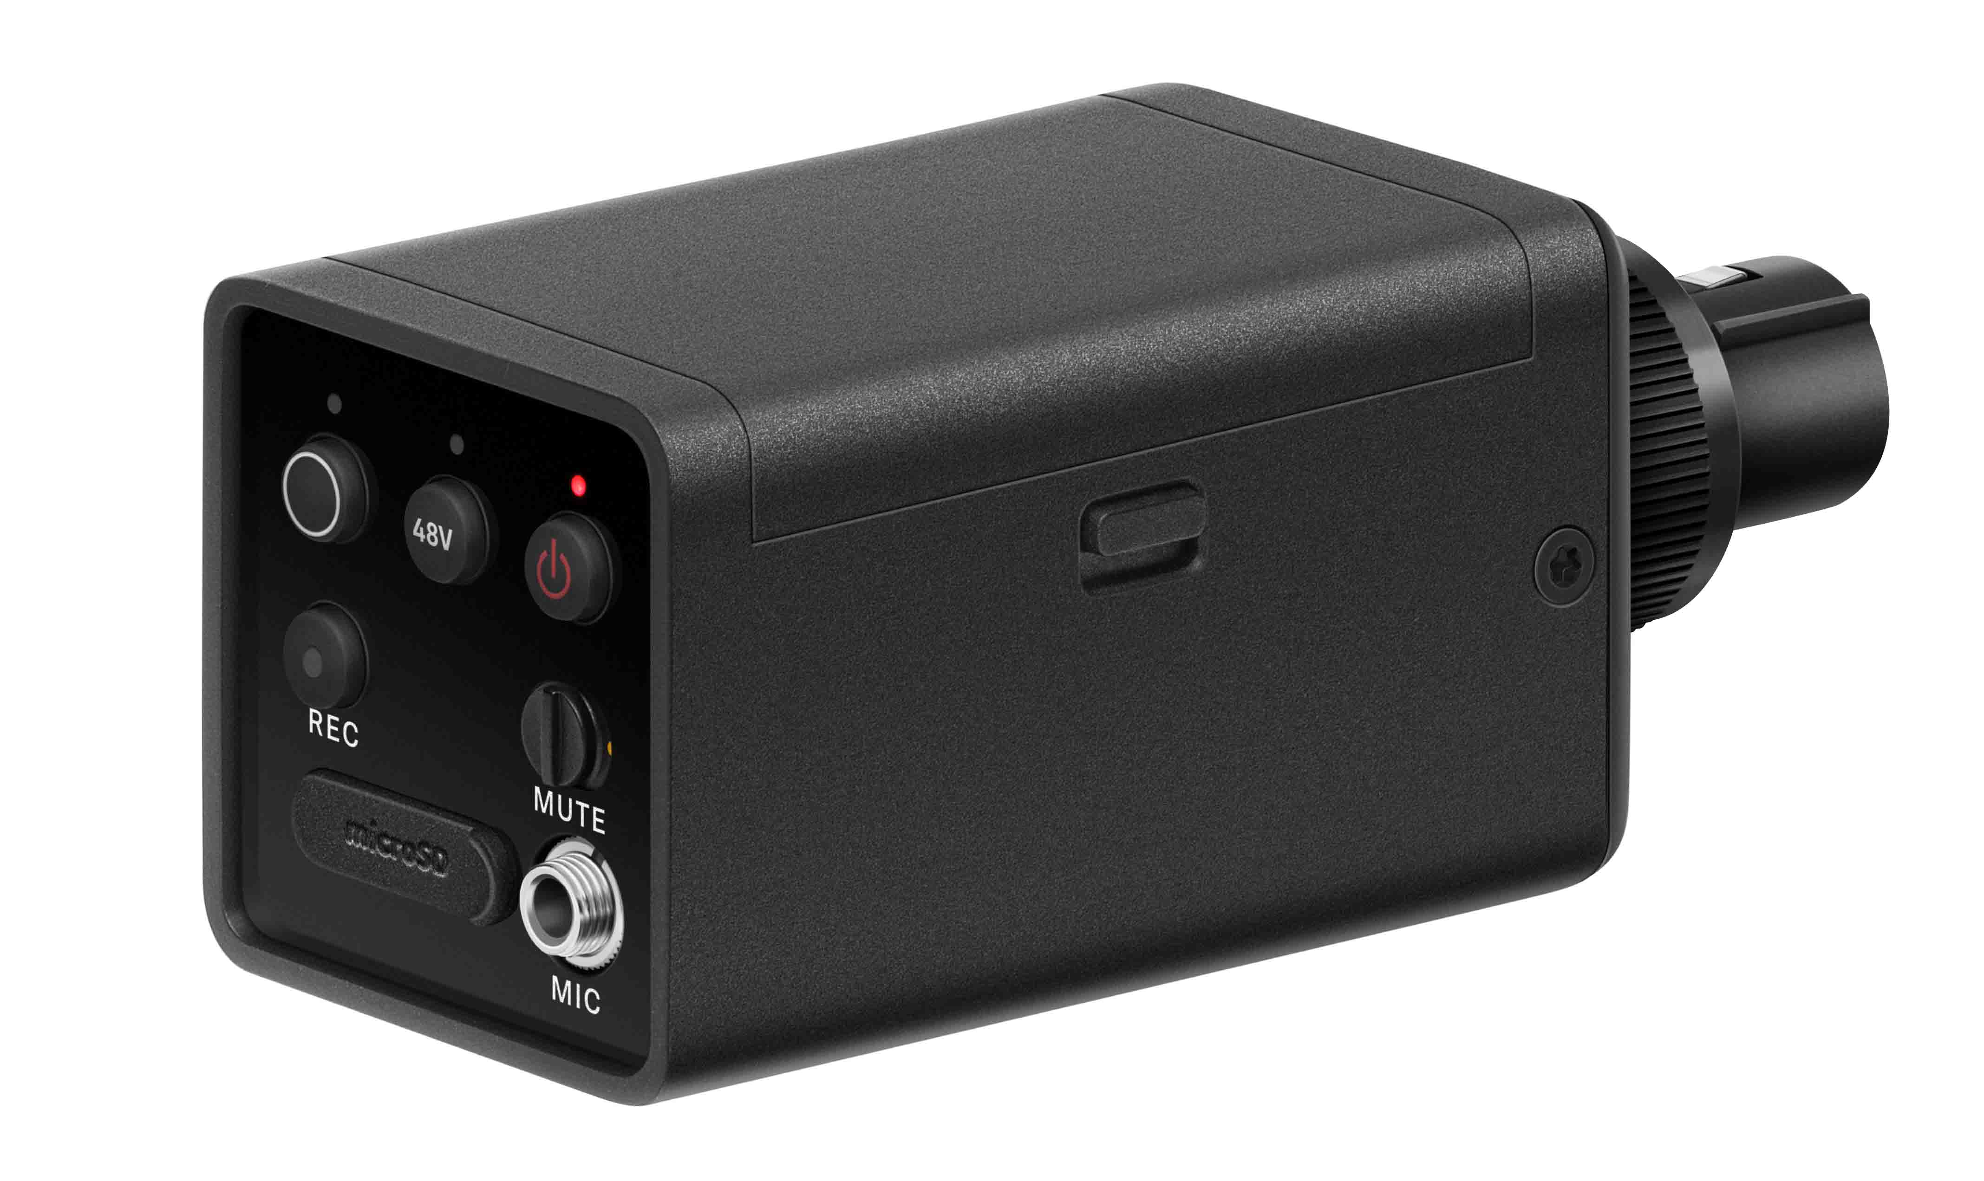 |  | The EW-DP SKP plug-on transmitter combines on-board 32-bit float recording with an industry-leading 134 dB of dynamic range

Versatile and flexible
The SKP is the most versatile family member of Evolution Wireless Digital, as it can be connected to dynamic and condenser XLR microphones (+48 V phantom power on board) as well as to lavalier mics with a 3.5 mm jack connector. Its low-cut filter can be switched off, so the SKP can also serve as an adjustment tool for PA systems. “In a nutshell: The EW-DP SKP is the best plug-on transmitter that Sennheiser has ever manufactured,” says von Allwörden.

With +48V phantom power on board, the EW-DP SKP will be able to turn any wired XLR microphone, such as an MKH 416 on a boom pole, into wireless | 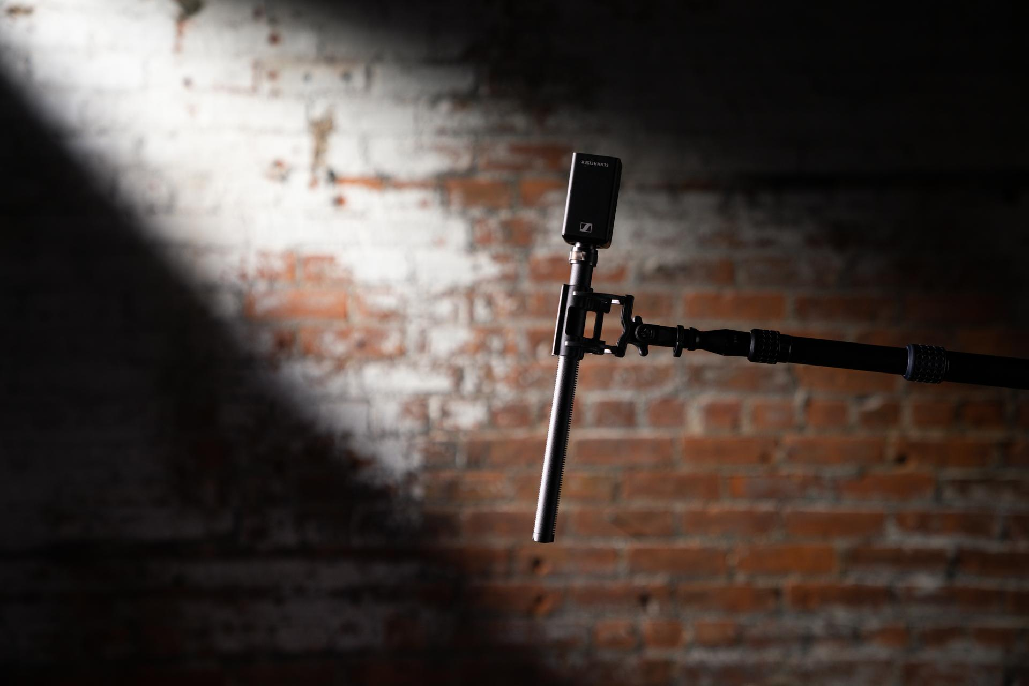

The plug-on transmitter is powered by the BA 70 rechargeable battery or by two AA batteries. It will be available separately or as part of the EW-DP ENG SET, which additionally includes the stackable EW-DP EK camera receiver and a bodypack transmitter with an ME 2 lavalier mic, giving videographers more options for recording their audio.

The system comes complete with a magnetic mounting plate kit, a BA 70 rechargeable battery, two standard AA batteries, a locking 3.5 mm TRS to 3.5 mm TRS cable, a locking 3.5 mm TRS to XLR cable, and a USB-C charging cable for the receiver.

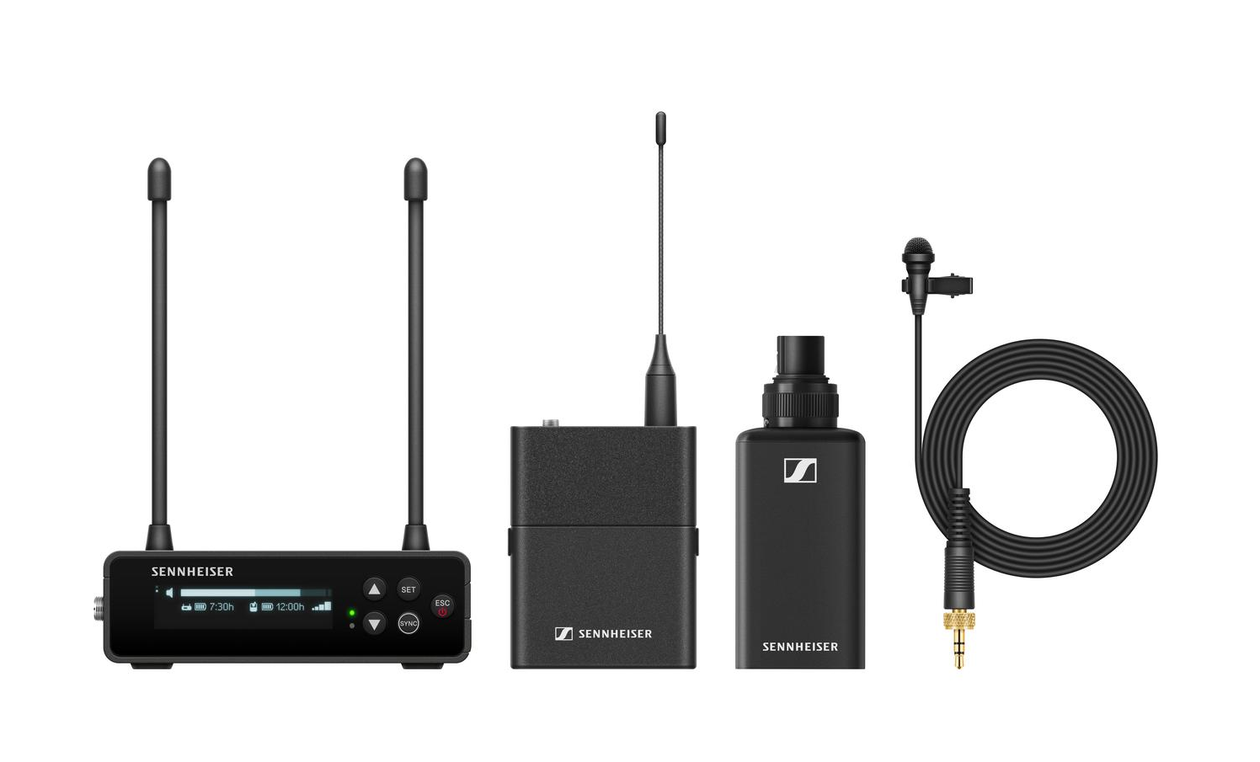 | The EW-DP SKP plug-on transmitter will also be part of the EW-DP ENG SET

About EW-DP
Purpose-built for filmmaking and video applications, EW-DP is a fully digital UHF wireless microphone system with a new portable design and unmatched audio quality. At its heart is a compact, intelligent receiver that helps even novice users set up their audio with ease. The EW-DP EK receiver features an innovative magnetic stacking system and a user-facing OLED display, and can be conveniently controlled remotely via the Smart Assist app (new 2.0.5 update including the 1.9.0 update for the EW-DP EK receiver firmware available now at www.sennheiser.com/smart-assist-app). Thanks to EW-DP’s automated frequency coordination, videographers can get up and running quickly. EW-DP is not only intuitive and fast to set up but also helps users to troubleshoot their system. If any issues should occur, the system will guide users with Smart Notifications that give tips for troubleshooting and show them where to fix a problem.

Technical Data
EW-DP SKP
Input voltage: 2.0 - 4.35 V
Input current: < 300mA (without Recording & P48)
Power supply: 2 AA batteries 1.5 V (alkali manganese) or BA 70 rechargeable battery pack
Occupied bandwidth: 200 kHz
Transmit power (radiated): Audio link: 10 mW ERP; BLE: max. 10 mW EIRP
Dimensions: 108 x 42 mm
Weight (without batteries): approx. 163 g

System
Audio link frequency ranges: Q1-6: 470.2 - 526 MHz; R1-6: 520 - 576 MHz; R4-9: 552 - 607.8 MHz; S1-7: 606.2 - 662 MHz; S4-7: 630 - 662 MHz; S7-10: 662 - 693.8 MHz; U1/5: 823.2 - 831.8 MHz & 863.2 - 864.8 MHz; V3-4: 925.2 - 937.3 MHz; Y1-3 1785.2 - 1799.8 MHz
Bluetooth® Low Energy (BLE) frequency range: 2402 - 2480 MHz
Audio frequency response: 20 Hz - 20 kHz (-3 dB) @ 3 dBfs
Audio THD: ≤ -60 dB for 1 kHz @ -3 dBfs input level
Input dynamic range: 134 dB
System latency: 1.9 ms
Operating temperature: -10 °C - +55 °C (14 °F - 131 °F)
Charging temperature: 0 °C - +55 °C (32 °F - 131 °F)
Relative humidity 5 - 95 % (non-condensing)

(Ends)

The images accompanying this media release and additional photos can be downloaded here.

About the Sennheiser brand
We live and breathe audio. We are driven by the passion to create audio solutions that make a difference. Building the future of audio and bringing remarkable sound experiences to our customers – this is what the Sennheiser brand has represented for more than 75 years. While professional audio solutions such as microphones, meeting solutions, streaming technologies and monitoring systems are part of the business of Sennheiser electronic GmbH & Co. KG, the business with consumer devices such as headphones, soundbars and speech-enhanced hearables is operated by Sonova Holding AG under the license of Sennheiser.

www.sennheiser.com
www.sennheiser-hearing.com

Global Pro Audio Press Contact
Stephanie Schmidt
stephanie.schmidt@sennheiser.com
+49 (5130) 600 – 1275

